**BASICS OF SQL II**

**SQL JOINS:**

Sample Customer and Employee table are created.

MYSQL> select * from customer;

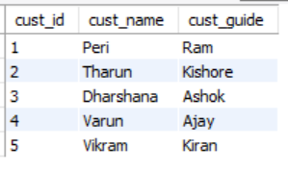

MYSQL> select * from employee;

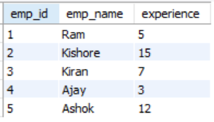

MYSQL> select a.cust_name, b.emp_name from customer a inner join employee b where a.cust_guide = b.emp_name;

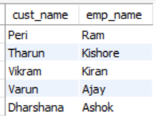

**SQL UNION:**

MYSQL> select cust_name from customer UNION select emp_name from employee;

Makes a union of unique elements of similar no.of columns.

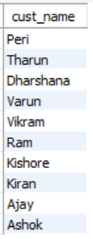

**SUBQUERIES:**

MYSQL> select * from customer where cust_guide in (select emp_name from employee where experience > 10);

